
Sreenidhi Institute of Science & Technology
A 10
(An Autonomous Institution)
Code No: 103MB12

MASTER OF BUSINESS ADMINISTRATION, I - YEAR II - SEM, July, 2012
(SUPPLEMENTARY)
QUANTITATIVE ANALYSIS & BUSINESS DECISIONS

Time: 3 Hours Max. Marks : 60

Note : No additional answer sheets will be provided.

------------------------------------------------------------------------------------------------------------------------------
ANSWER ANY FIVE QUESTIONS
1. Answer any Three of the following. [ 4 + 4 + 4 ]
a. What is alternative optimum solution in Transportation problems?
b. What is meant by degeneracy in T.P. ?
c. Explain the arrival pattern in queuing Theory.
d. Define the critical path.
e. Draw a network diagram for the following information.
Name of the activity | Predecessor activity
A | --
B | --
C | --
D | A
E | B
F | C
G | D,E
H | B
I | H,F

- What is model ? Discuss various classification schemes of models in operations research ?
- Explain and differentiate this under the conditions of certainty and Uncertainty ?
4. A department head has four subordinates and four tasks to be performed. The subordinates differ in efficiency and the task differ intrinsic difficulty, his estimate of the time, each man would be take to perform each task is given in the matrix below.
Tasks | Men
Tasks | E | F | G | H
A | 18 | 26 | 17 | 11
B | 13 | 28 | 14 | 26
C | 38 | 19 | 18 | 15
D | 19 | 26 | 24 | 10
How should be task be allocated one to a man, so as to minimize the total man hours ?
5. Solve the following LPP by dual simplex method.
Min Z = 2x₁ + x₂
Subject to constraints :
3x₁ + x₂ 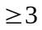
4x₁ + 3x₂ 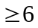
x₁ + 2x₂
and x₁, x₂ 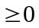
6. Use dominance principle to reduce the following game in to 2 x 2 game hence find optimal strategies and value of the game.
Player B
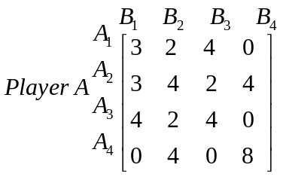
- A firm is thinking of replacing a particular machine. Whose cost price is `12,200. The Scrap price of this machine is only ` 200. The maintenance costs are found to be as fellows.
Year : | 1 | 2 | 3 | 4 | 5 | 6 | 7 | 8
Maintenance cost : ` | 220 | 500 | 800 | 1200 | 1800 | 2500 | 3200 | 4000

Determine when the firm should get the machine replaced ?
-- 00 -- 00 --

